Test Cases:

1. 3 Clients connecting normally

Open the server with parameter port = 9999 max_user = 3.

Open 3 clients with username ‘User1’ ‘User2’ ‘User3’ separately.

This shows the result:

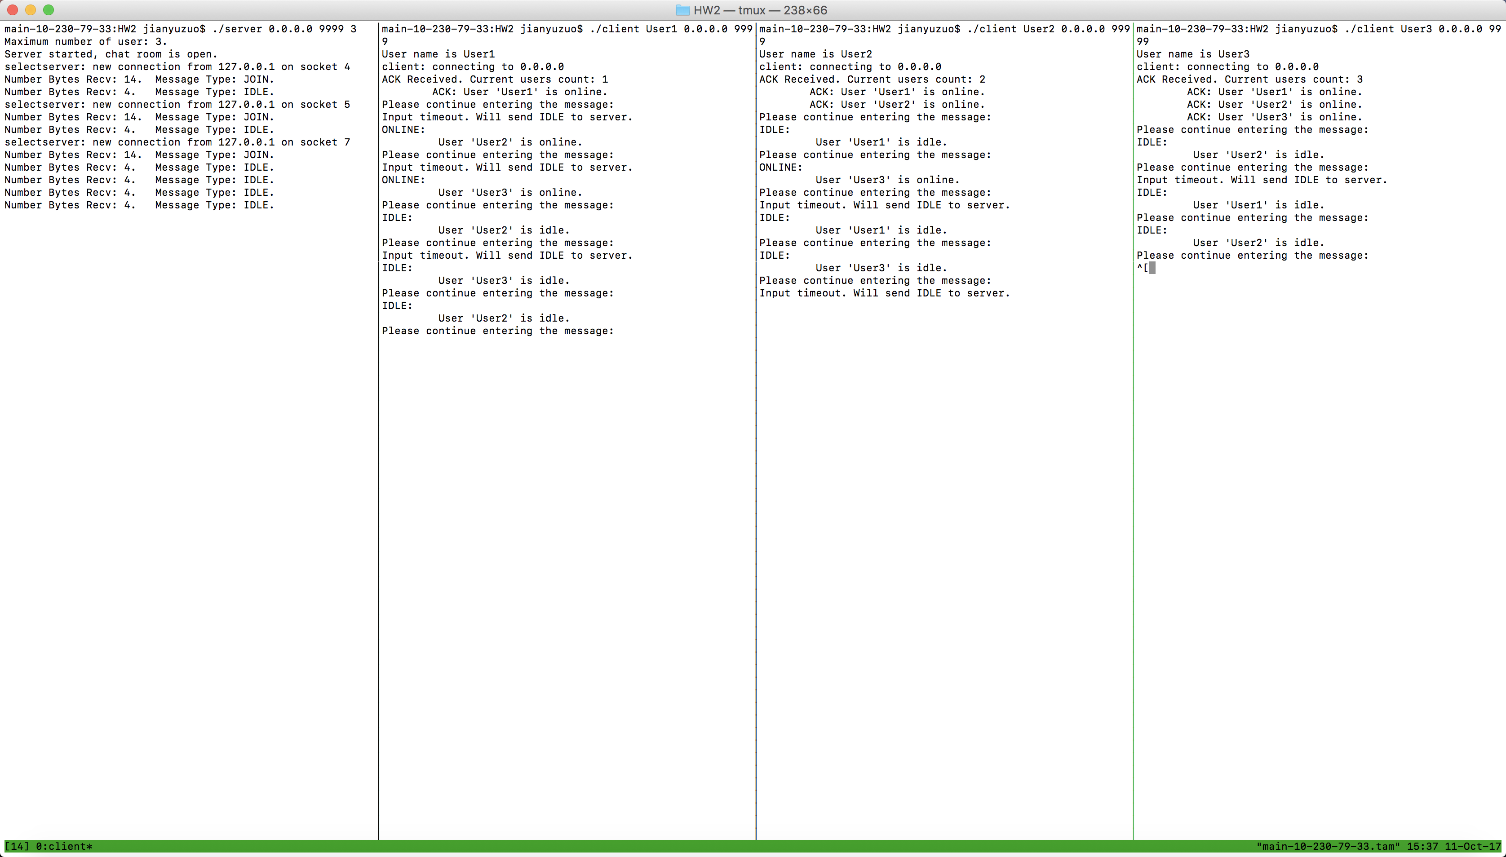

This picture also shows that each time a new client that tries to join the room, if succeeded, the client will receive an ACK indicating the users that are in the room.

1. Duplicate username

We then close the third client, which has username ‘User3’. We then try to connect the server with username ‘User2’, which is already used for the second client. The following picture shows the result, which is an NAK received from the server.

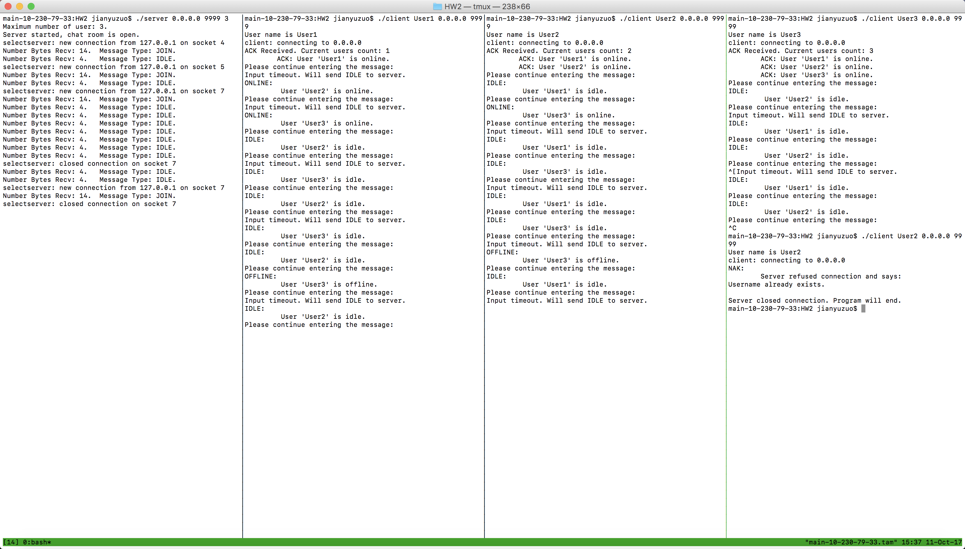

1. Previously used username reconnection

After the above steps, there should be only 2 users in the room, which are ‘User1’ and ‘User2’. We then try to connect the server in third client using the same previous username ‘User3’ and gives the following result:

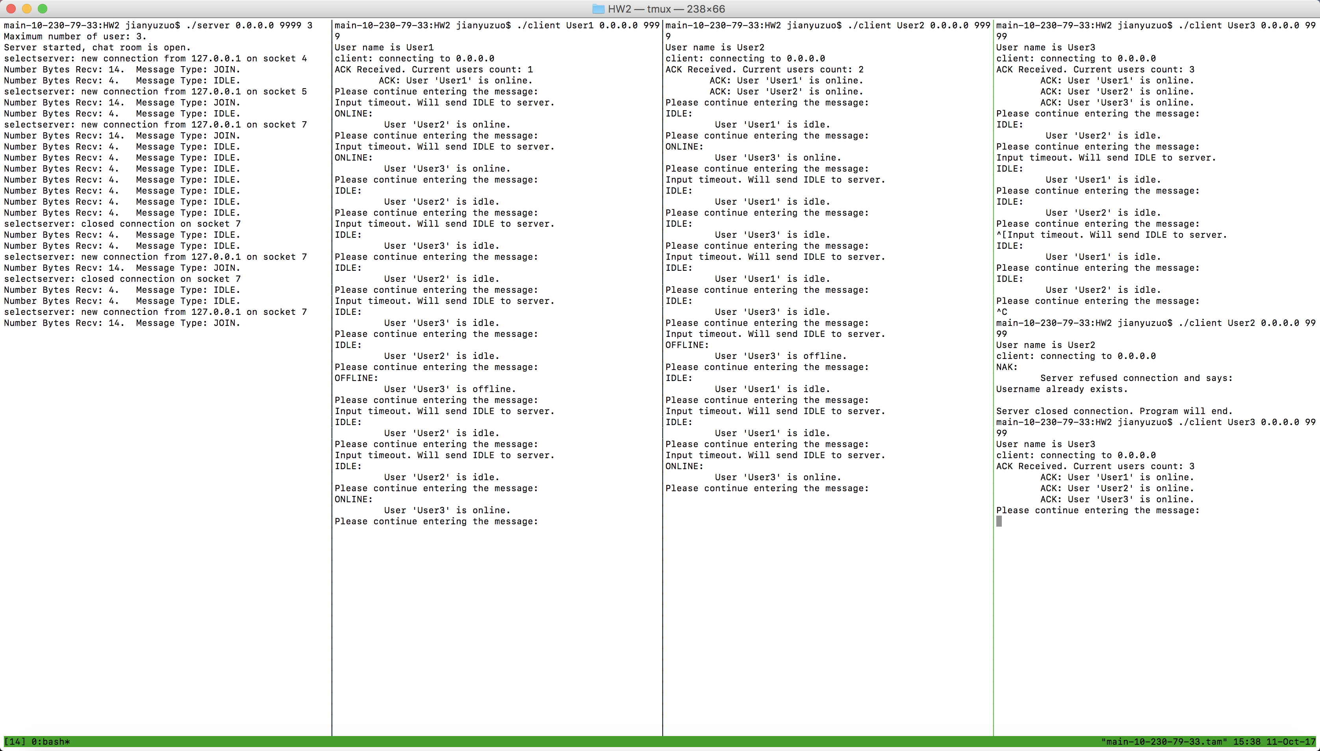

1. Maximum room capacity

Now the room should have 3 users. Meanwhile, the maximum acceptable users count for the user is 3, too. So we try add a new user ‘User4’ to connect to the server and get the following result:

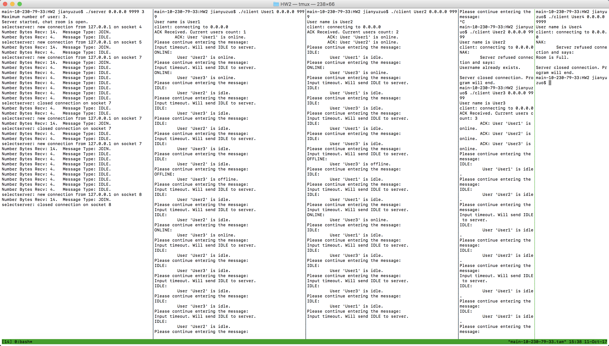

This shows that the server refused the JOIN request from ‘User4’ and closed the connection with that client. The server offers a NAK reason why connection refused.

1. BONUS features:
2. IPv6 Support:

Restart the server, given ipv6 format address

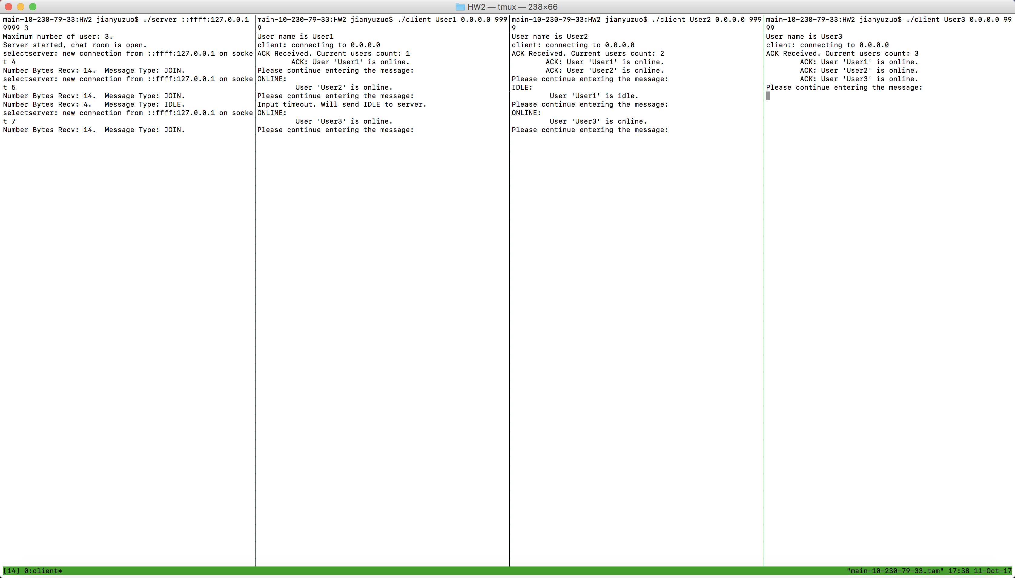

From this result, the server supports IPv6 addresses.

1. The new message Types NAK ACK ONLINE OFFLINE and IDLE is shown in the above pictures. The following is an extra test on such message types.

